**EE387: Signal Processing**

**Lab 3: System Functions and Frequency Response**

Ranage R.D.P.R. - E/19/310

**PART 1: Pole-Zero Diagrams in MATLAB.**

**Using the method given above, find out the zeros and poles of the following system functions and plot them:**



clear all;

close all;

subplot(2,2,1)

b = [1 -1]; % Numerator coefficients

a = [1 3 2]; % Demoninator coefficients

zs = roots(b); % Generetes Zeros

ps = roots(a); % Generetes poles

pzmap(ps,zs); % generates pole-zero diagram

n1=[1,5];

d1=[1,2,3];

zeros1=roots(n1);

poles1=roots(d1);

subplot(2,2,2);

pzmap(poles1,zeros1);

n2=[2,5,12];

d2=[1,2,10];

zeros2=roots(n2);

poles2=roots(d2);

subplot(2,2,3);

pzmap(poles2,zeros2);

n3=[2,5,12];

d3=conv([1,2,10],[1,2]);

zeros3=roots(n3);

poles3=roots(d3);

subplot(2,2,4);

pzmap(poles3,zeros3);

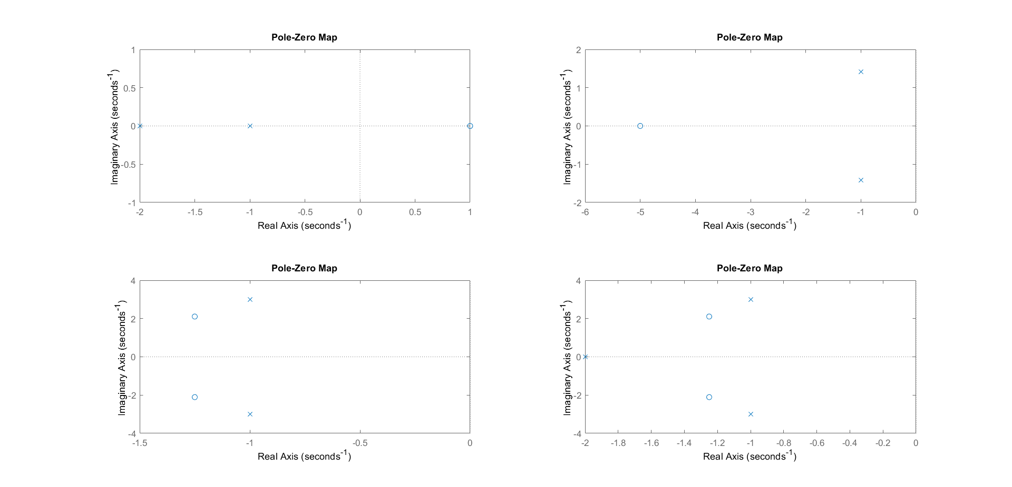

**PART 2: Frequency Response and Bode Plots in MATLAB**

**Consider a system function:**

**1. Define the numerator and denominator polynomial coefficients as vector b and a respectively.**

**2. Use the freqs function to evaluate the frequency response of a Laplace transform.**

H = freqs(b,a,omega);

**Where is the frequency vector in rad/s. (Hint: use linspace to generate a vector with 200 samples.)**

**3. Plot the magnitude and phase of the frequency response.**

**4. Plot the bode plot of the given H(s) by utilizing the results in 2. (Hint: use the definitions of the bode plot)**

b=[2,2,17];

a=[1,4,104];

omega=linspace(-20,20,200);

H=freqs(b,a,omega);

subplot(2,1,1);

plot(omega,abs(H))

xlabel('omega / (rad/s))');

ylabel('magnitude of response');

subplot(2,1,2);

plot(omega,phase(H))

xlabel('omega / (rad/s))');

ylabel('phase of response');

figure;

subplot(2,1,1)

semilogx(omega,10*log(abs(H)));

xlabel('omega / (rad/s))');

ylabel('magnitude / (dB)');

subplot(2,1,2)

semilogx(omega,phase(H));

xlabel('omega / (rad/s))');

ylabel('phase');

figure

bode(tf(b,a))

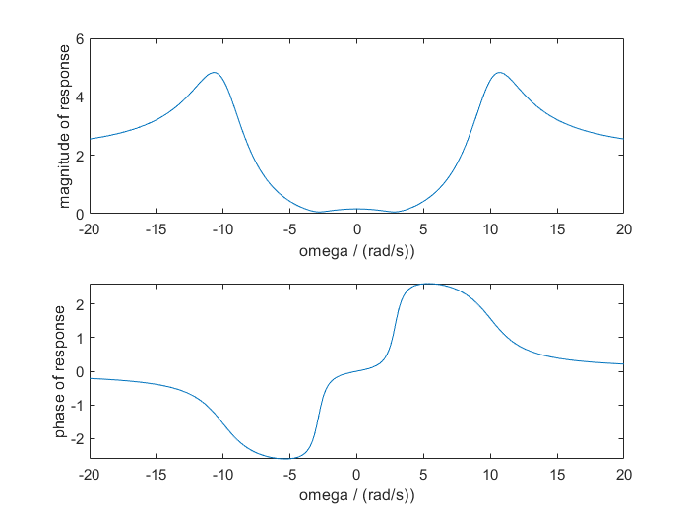

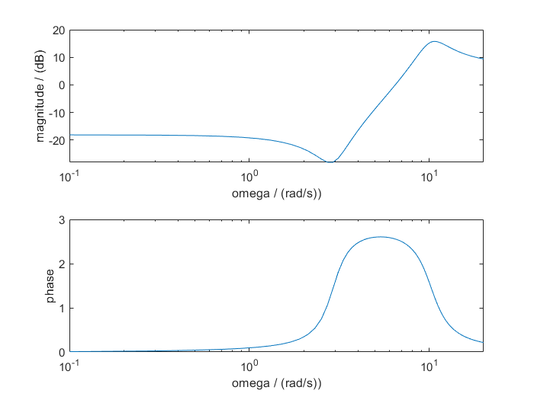

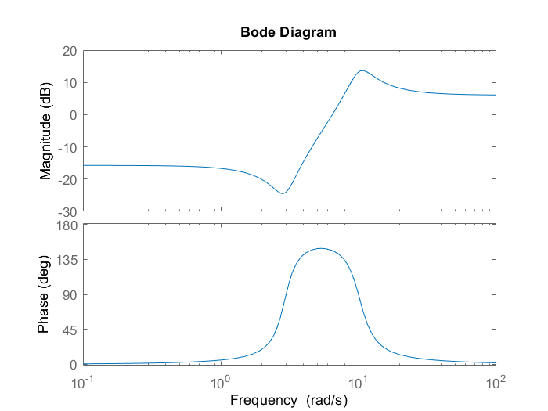

**Exercise**

**1. Plot the bode plot of each four system functions given in the part 1.**

**2. Select three sinusoidal signals with unit magnitude, zero phase and three different frequencies (*f1,f2,f3 in kHz, here fi = Registration number * i*). Assume that they are three inputs for abovementioned four systems. Then find the corresponding three outputs for each system.**

*fi* = 310 kHz

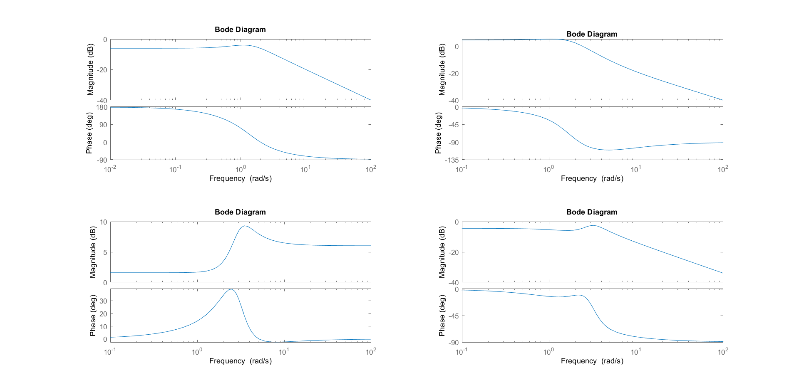

f= 310 kHz

x(t)=sin(2*pi*310)

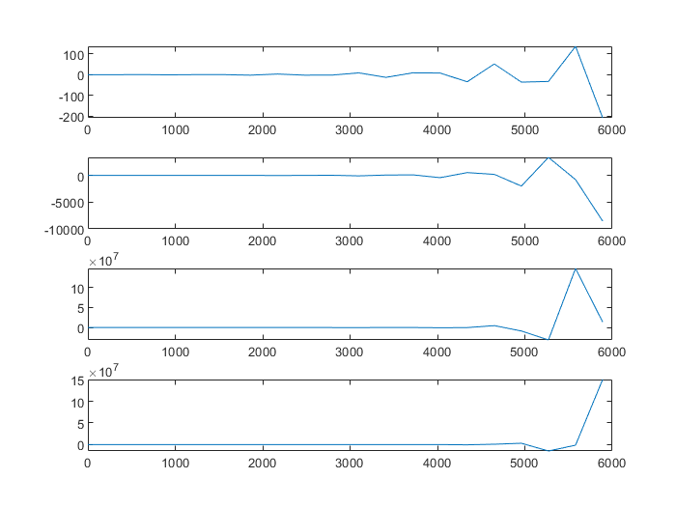

f=310*2Hz

x(t)=sin(2*pi*620)

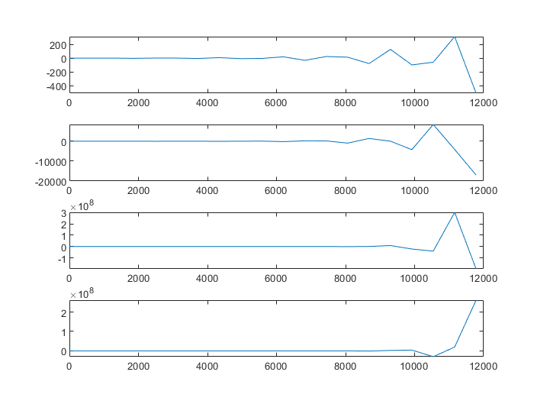

f=310*3Hz

x(t)=sin(2*pi*930)

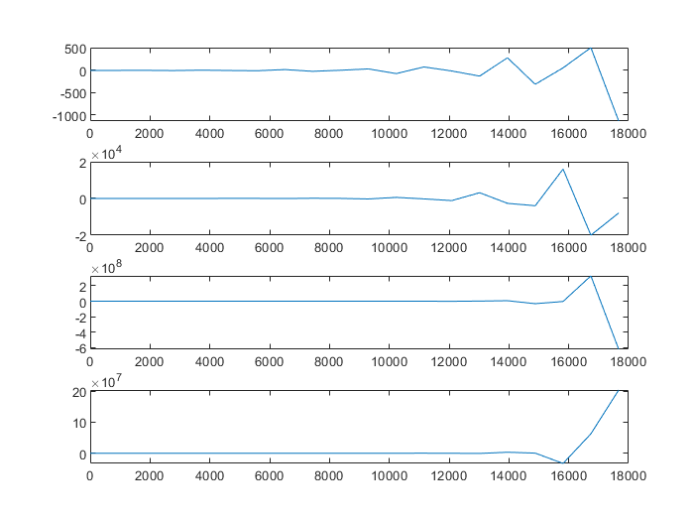

**PART 3: Surface Plots of a System Function in MATLAB**

**Where are the poles and zeros on the surface plot? What’s the relationship between the surface plot and the plot in 2.(2) ?.**

clear all;

close all;

omega = -20 : 0.1 : 20;

sigma = -5 : 0.1 : 5;

[sigmagrid, omegagrid] = meshgrid(sigma, omega);

sgrid = sigmagrid + 1i*omegagrid;

b = [2 2 17];

a = [1 4 104];

H1 = polyval(b, sgrid)./polyval(a, sgrid);

mesh(sigma, omega, 20*log10(abs(H1)));

xlabel('sigma');

ylabel('omega');

zlabel('abs(H1)');

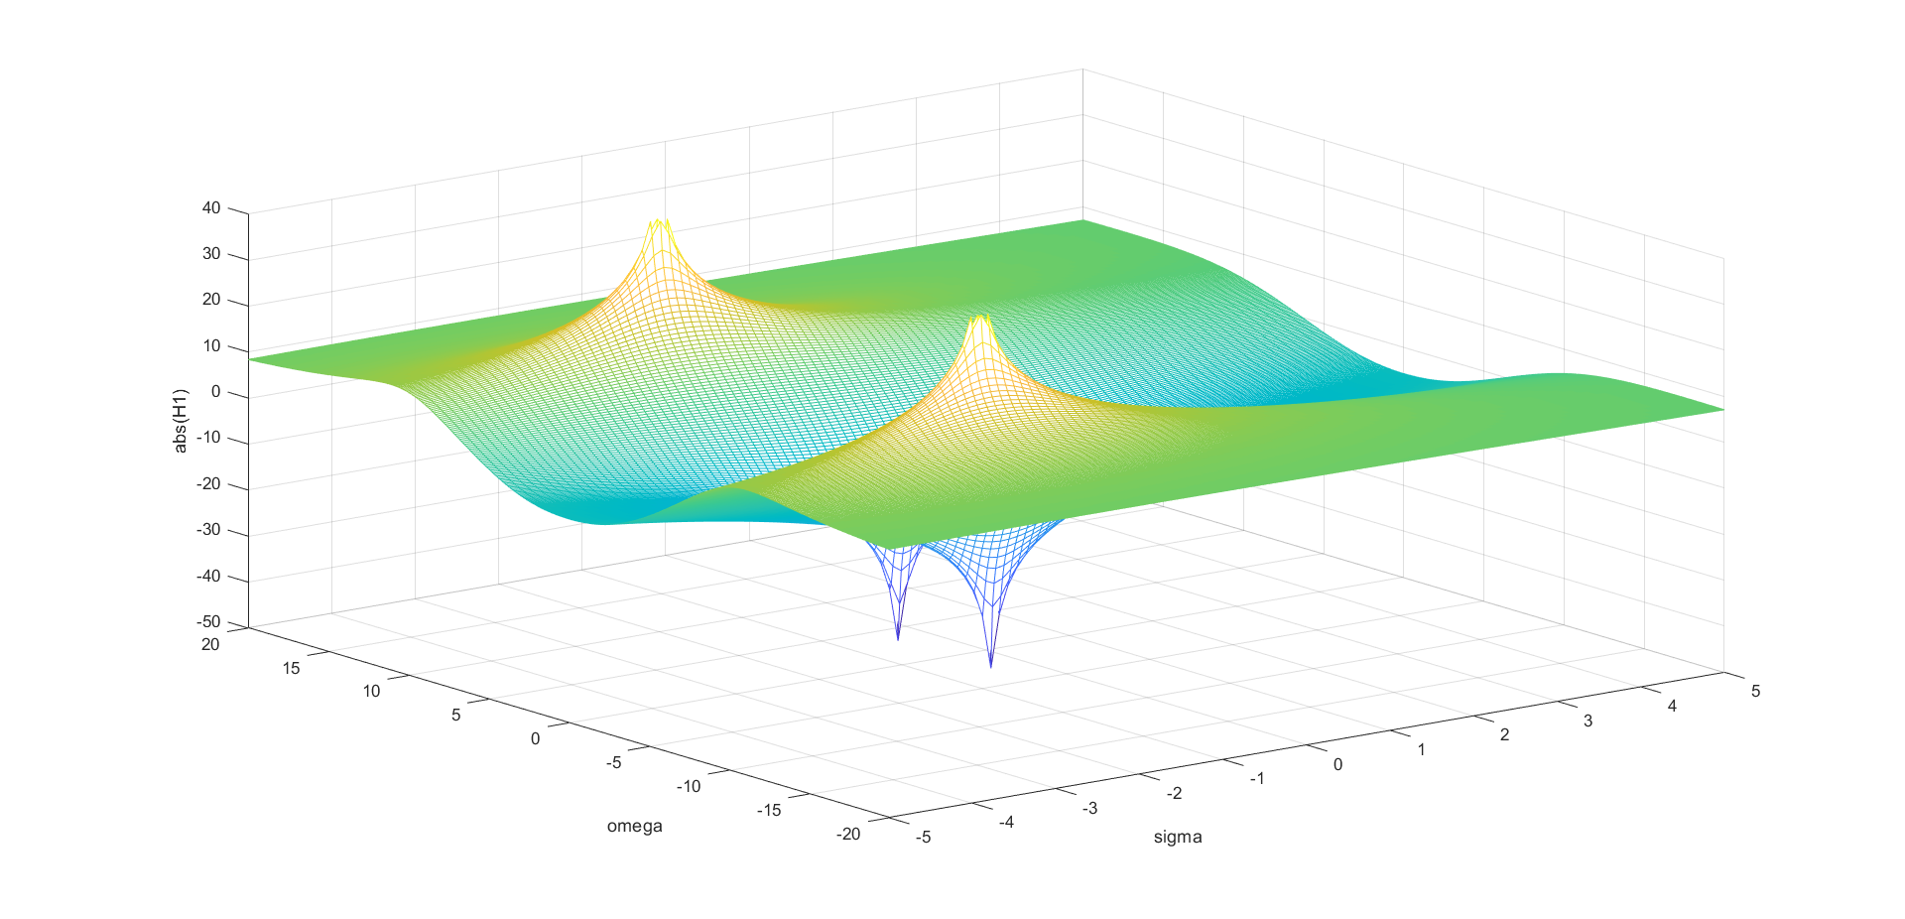

**Poles:** The points on the surface plot where the magnitude of H(s)H(s)H(s) goes to infinity are known as the poles. This is due to the fact that at certain places, the denominator of H(s)H(s)H(s) approaches zero.

**Zeros:** The places where H(s)H(s)H(s) has a zero magnitude are known as the zeros. This is because at these sites, the numerator of H(s)H(s)H(s) is zero.